**In ML the most important algorithm used is K-means Clustering ... K-means Clustering is one of the simplest and popular unsupervised machine learning algorithms. A cluster refers to a collection of similar items together.**

**So try to build K-mean cluster in python (screenshot for each stage). ?!**

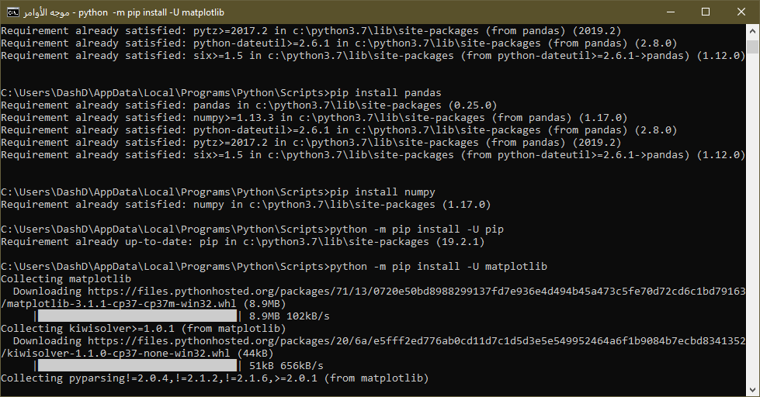





|  |  |  |  |  |  |  |  |  |  |  |  |  |  |  |  |  |  |  |  |  |  |  |  |  |  |  |  |  |  |  |  |  |  |  |  |  |  |  |  |  |  |  |  |  |  |  |  |  |  |  |  |  |  |  |  |  |  |  |  |  |  |  |  |
| --- | --- | --- | --- | --- | --- | --- | --- | --- | --- | --- | --- | --- | --- | --- | --- | --- | --- | --- | --- | --- | --- | --- | --- | --- | --- | --- | --- | --- | --- | --- | --- | --- | --- | --- | --- | --- | --- | --- | --- | --- | --- | --- | --- | --- | --- | --- | --- | --- | --- | --- | --- | --- | --- | --- | --- | --- | --- | --- | --- | --- | --- | --- | --- |
| **1-Data set:**   |  |  | | --- | --- | | **x** | **y** | | 25 | 79 | | 34 | 51 | | 22 | 53 | | 27 | 78 | | 33 | 59 | | 33 | 74 | | 31 | 73 | | 22 | 57 | | 35 | 69 | | 34 | 75 | | 67 | 51 | | 54 | 32 | | 57 | 40 | | 43 | 47 | | 50 | 53 | | 57 | 36 | | 59 | 35 | | 52 | 58 | | 65 | 59 | | 47 | 50 | | 49 | 25 | | 48 | 20 | | 35 | 14 | | 33 | 12 | | 44 | 20 | | 45 | 5 | | 38 | 29 | | 43 | 27 | | 51 | 8 | | 46 | 7 | | **2-Capture data using pandas (matche data-set):** |
| **3- 3-clusters ,matplotlib module & applying K-Means Clustering using sklearn:** |
|  |
|  | **4-chik Scatter plot:** |
|  | **5- Cluster:** |
|  |  |